WEEK 3 ASSIGNMENT
Building Advanced Data Models
and DAX Calculations
Power BI for Virtual Construction Business Intelligence

Prepared by | Your Name
Programme | Virtual Construction Business Intelligence Internship
Submission | Week 3
Prepared for academic and internship assessment

1. Executive Summary
This report presents a conceptual Power BI data model for monitoring virtual construction projects. The model combines project details, dates, resources, locations, planned costs, actual costs, and progress records. A star-schema design is proposed to make analysis easier to understand and maintain. Three key performance measures—budget variance, cumulative project cost, and cost performance index—are defined in DAX and explained in the context of construction project control.

2. Objective and Scope
The objective is to design a reusable data model that connects project timelines, budgets, resource allocation, and cost transactions. The model should allow project managers and business intelligence analysts to review spending trends, compare actual costs with plans, and evaluate the cost efficiency of completed work. The model is a conceptual design; column names should be aligned with the source data before implementation.

3. Data Model Design
A star schema is recommended. FactProjectCosts is the central fact table and contains measurable project activity at a consistent reporting grain. Dimension tables describe the project, date, resource, and location. Each dimension has a unique key and filters the fact table through a one-to-many relationship.
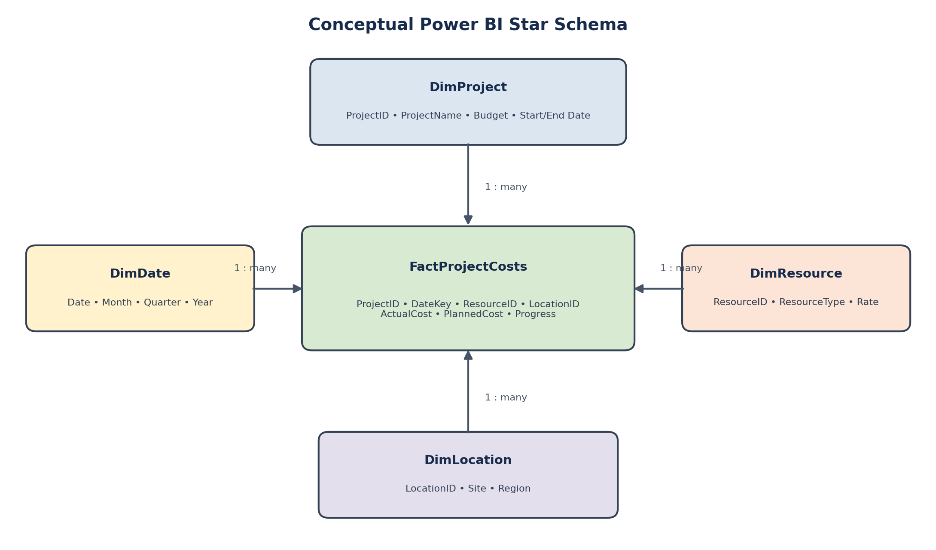
Figure 1. Conceptual star schema for construction cost and progress analysis.

4. Table Definitions
Table | Important columns | Purpose
FactProjectCosts | ProjectID, DateKey, ResourceID, LocationID, ActualCost, PlannedCost, Progress | Stores cost and progress observations. Each row should represent a defined transaction or reporting-period record.
DimProject | ProjectID, ProjectName, ApprovedBudget, StartDate, PlannedEndDate, Status | Provides project attributes and approved budget information.
DimDate | Date, DateKey, Month, Quarter, Year | Enables daily, monthly, quarterly and annual time analysis.
DimResource | ResourceID, ResourceType, ResourceName, StandardRate | Supports labour, equipment and resource-level analysis.
DimLocation | LocationID, SiteName, Region, ProjectArea | Enables site, area and region comparisons.

5. Relationships and Filtering
- DimProject[ProjectID] → FactProjectCosts[ProjectID]. One-to-many; one project can have many cost/progress records.
- DimDate[Date] → FactProjectCosts[DateKey]. One-to-many; one date can be associated with many records.
- DimResource[ResourceID] → FactProjectCosts[ResourceID]. One-to-many; a resource can appear in multiple records.
- DimLocation[LocationID] → FactProjectCosts[LocationID]. One-to-many; a site or region can be linked to multiple records.
Use single-direction filtering from dimension tables to the fact table wherever possible. This reduces ambiguity and makes DAX measures easier to reason about. Ensure dimension keys are unique and that data types match on both sides of each relationship. Mark DimDate as the model's date table in Power BI.

6. DAX Measures and KPI Explanations
The following measures assume that the fact table contains the listed columns and that cost values use one consistent currency.

6.1 Base measures and budget variance
Total Actual Cost =
SUM ( FactProjectCosts[ActualCost] )
Total Planned Cost =
SUM ( FactProjectCosts[PlannedCost] )
Budget Variance =
[Total Actual Cost] - [Total Planned Cost]
Budget Variance % =
DIVIDE ( [Budget Variance], [Total Planned Cost], 0 )
Purpose: Budget variance compares actual expenditure with planned expenditure. A positive value means actual cost is higher than planned cost (overspending); a negative value means actual cost is lower than planned cost. The percentage measure normalizes the difference relative to planned cost. DIVIDE avoids a divide-by-zero error.
Example: if actual cost is 120,000 and planned cost is 100,000, the variance is 20,000 and variance percentage is 20%.

6.2 Cumulative project cost
Cumulative Project Cost =
VAR CurrentDate = MAX ( DimDate[Date] )
RETURN
CALCULATE (
[Total Actual Cost],
FILTER (
ALLSELECTED ( DimDate[Date] ),
DimDate[Date] <= CurrentDate
)
)
Purpose: This running-total measure adds actual cost from the beginning of the selected date range through the current date in a visual. ALLSELECTED retains external date selections while allowing the measure to accumulate across dates within that selection. It is useful for line charts that compare cumulative spend with a planned cost curve.
Implementation note: DimDate must contain a continuous date range and have an active relationship to the date key in FactProjectCosts. If the intended running total must always start at project inception regardless of slicers, the date-filter logic should be adjusted.

6.3 Earned value and Cost Performance Index (CPI)
Earned Value =
SUMX (
FactProjectCosts,
FactProjectCosts[PlannedCost] * FactProjectCosts[Progress]
)
Cost Performance Index =
DIVIDE ( [Earned Value], [Total Actual Cost], 0 )
Purpose: Earned Value approximates the budgeted value of completed work by multiplying each record's planned cost by its progress fraction. CPI divides earned value by actual cost. CPI above 1 indicates more budgeted work value earned per unit of cost; CPI below 1 indicates cost inefficiency against this measure.
Assumptions and caution: Progress must be numeric and stored as a decimal from 0 to 1 (for example, 50% = 0.5). PlannedCost must represent the budgeted value of the work associated with each row. If progress is repeated across multiple cost transactions, this formula may double-count earned value. In a production model, store progress at a suitable work-package or reporting-period grain and use a validated earned-value field when available.

7. Optional Extension: Estimated Completion Date
A forecast completion date should only be calculated when the model contains reliable progress history, remaining work estimates, and a meaningful measure of delivery rate. A simple projection can estimate remaining duration as remaining work divided by average daily completed work, then add that duration to the current date. This is a planning estimate, not a guarantee, and should be validated against project calendars, dependencies, resource constraints, and holidays.

8. Design Assumptions and Data Quality Controls
- Every project, date, resource and location has a valid key; dimension keys are unique.
- ActualCost and PlannedCost use the same currency and consistent accounting treatment.
- FactProjectCosts has a documented grain, such as one record per project, work package, resource and reporting date.
- Progress is expressed as a decimal between 0 and 1 and has a clearly documented definition.
- DimDate is continuous and includes every date required for analysis.
- Missing or duplicated transactions are investigated before KPI results are used for decisions.
- Budget values are distinguished from periodic planned costs; the approved project budget should not be summed repeatedly from a dimension table.
- Security, access control and project confidentiality are configured separately in the Power BI model where needed.

9. Strengths and Limitations

Strengths
- The star schema is intuitive and supports efficient filtering and aggregation.
- Reusable DAX measures keep KPI definitions consistent across report pages.
- Time-based analysis can expose cost acceleration and emerging budget risks.
- Project, resource and location dimensions allow users to compare performance at different levels.

Limitations
- Poor-quality or late data can make cost and progress indicators misleading.
- Incorrect fact-table grain or repeated progress percentages can distort earned-value calculations.
- A simple CPI measure does not account for every schedule, quality or contractual factor.
- Forecast completion dates require sufficient historical observations and should include uncertainty.
- Very large fact tables may require performance tuning, incremental refresh, aggregation tables or simplified calculations.

10. Validation and Testing Plan
- Reconcile total actual costs with a trusted source report.
- Check that each dimension key maps to the correct fact records and that there are no unintended many-to-many relationships.
- Test budget variance using a small hand-calculated example.
- Test cumulative cost by date and confirm that the total increases as expected.
- Validate CPI against a sample work package where planned cost, progress and actual cost are known.
- Use slicers for project, date, resource and location to confirm that measures respond as expected.

11. Conclusion
The proposed Power BI model provides a structured foundation for virtual construction business intelligence. The star schema connects project, date, resource and location context to cost and progress observations. DAX measures for budget variance, cumulative cost and CPI provide complementary views of spending and cost efficiency. The reliability of these indicators depends on clear table grain, sound relationships, consistent cost definitions and validated progress data. The model can be extended with schedule variance, resource utilization, and evidence-based completion forecasts.

Appendix: Suggested Power BI Report Visuals
- KPI cards: Total Actual Cost, Total Planned Cost, Budget Variance %, and CPI.
- Line chart: Cumulative Project Cost by Date, optionally compared with a planned cumulative cost series.
- Bar chart: Budget Variance by Project or Location.
- Table or matrix: Project, planned cost, actual cost, variance, variance percentage, and CPI.
- Slicers: Project, date range, resource type and location.

